**DEVELOPMENT OF A DYNAMIC CURRENCY MANAGEMENT WEB APPLICATION: A COMPREHENSIVE FRONT-END AND BACK-END INTEGRATION**

**TABLE OF CONTENTS**

**Introduction** **3**

**Front End** **3**

**Back-end Development** **4**

**Database Management** **5**

**Conclusion** **6**

**Reference List** **7**

# 

# Introduction

This web application focuses on the management of currency rates. The application will produce existing rates, and a new data input will be taken without interruption to view all the rates. Different technologies and frameworks have been used for the creation of this project to design an interactive interface and a powerful backend system.

# Front End

The front end of the web application has been developed using ***HTML***, ***CSS***, and ***JavaScript***. The HTML structure has created the basic structure of the application with different areas for displaying current currency rates and a form to insert new currency data. The user interface of the application is quite intuitive and easy to navigate. It thus easily distinguishes between the home section, which is where users can view the rates, and the insert section, which allows them to submit new rates.

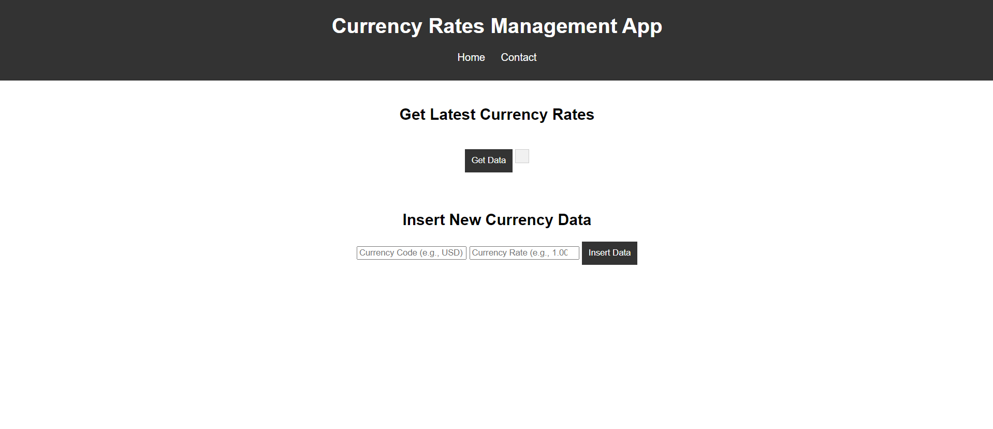

**Figure 1: Front page development**

(Source: Self-created)

As for style, CSS is applied in styling the application, offering it an excellent view and ensuring that the user has an advantage when it comes to its efficient usability (Odeniran, 2023). The design focused on responsibility to ensure that the application fits well with different sizes of screens and devices. To top it all, media queries were implemented to ensure that navigation and form elements are accessible and handy both in desktop and mobile platforms.

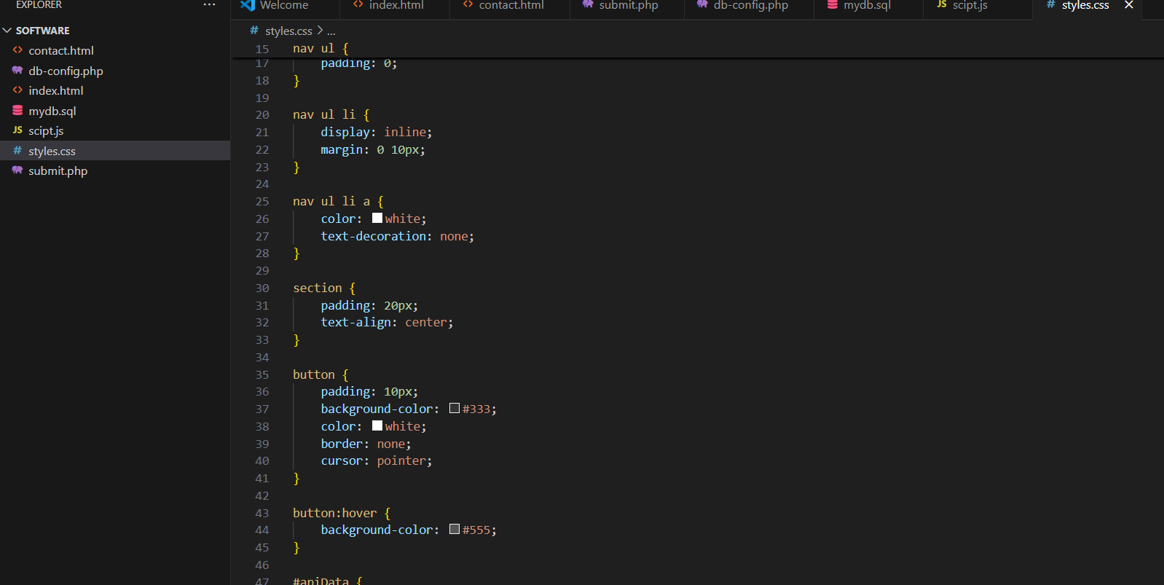

**Figure 2: CSS development**

(Source: Self-created)

JavaScript: This has been very important in the dynamic aspects of the application. The currency rates have been hardcoded into the script, and on click of the "Get Data" button, users can fetch and display the latest rates. This is done through event listeners that trigger an organized display of rates so that users get immediate feedback when using the application. Along with that, the JavaScript code implemented error handling to take care of any probable problem in fetching data, otherwise while displaying it.

# Back-end Development

PHP was used at the back end to catch the form submission from the front end, with a structured approach toward addressing user input for proper new currency rate handling and storage in a MySQL database. The PHP script has created an active connection with the database making use of ***my sql*** extension, ensuring secure interaction with the database.

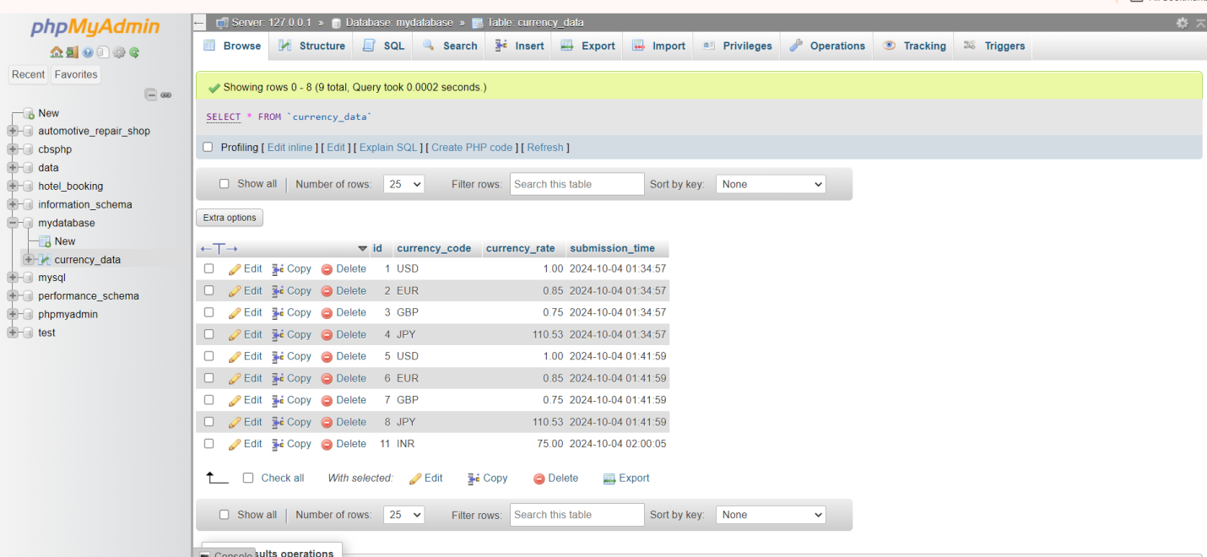

**Figure 3: PHP development**

(Source: Self-created)

Designed a PHP file specifically to handle form submission - `submit_data.php`. It involved adding validation checks to ensure that the submitted currency code and rate go through proper formatting before being inserted into the database (Goh *et al.,* 2023). The approach of prepared statements prevent SQL injection attacks.

A simple schema has been designed for the database using one table that is named `currency_data` and this contains all the records of currency code, rate, and timestamp for submission. SQL queries have been very efficient in creating new records while remaining organized for easy access to data (Sharma, 2021). Additionally, the error reporting features have been added to the application as this should help identify problems that may have occurred in the interaction process with the database.

# Database Management

The database has been administered using ***phpMyAdmin***; it's easy to administer the data. The structure has been created via SQL script, defining the involved tables and columns thereof (Baidauletov, and Salehin, 2020). Using this configuration made the administration of the data straightforward and ensured that all records were well-kept.

# Conclusion

The web application has successfully combined front-end and back-end technologies to offer fluent functionality for managing currency rates. This application has enabled users to enter and view currency data easily, therefore ensuring that it is securely processed and stored. Such successful implementation demonstrates good practice in web development and delivers practical tools for accessing currency information efficiently to users. The application not only completes the purpose but also establishes a base for possible further improvements and features in the future.

# Reference List

Odeniran, Q., 2023. Comparative Analysis of Fullstack Development Technologies: Frontend, Backend and Database. Retrieved from: <https://digitalcommons.georgiasouthern.edu/cgi/viewcontent.cgi?article=3883&context=etd> [Retrieved on: 25.09.2024]

Goh, H.A., Ho, C.K. and Abas, F.S., 2023. Front-end deep learning web apps development and deployment: a review. Applied Intelligence, 53(12), pp.15923-15945. Retrieved from: <https://link.springer.com/article/10.1007/s10489-022-04278-6> [Retrieved on: 25.09.2024]

Baidauletov, D. and Salehin, F., 2020. Integrating Modern Front-end Methodologies and Workflow in the Context of E-commerce Systems. Retrieved from: <https://www.theseus.fi/bitstream/handle/10024/334447/Baidauletov%20D.%20%26%20Salehin%20F.%20-%20Integrating%20Modern%20Front-End%20Methodologies%20and%20Workflow%20in%20the%20Context%20of%20E-Commerce.pdf?sequence=2> [Retrieved on: 25.09.2024]

Sharma, A.K., 2021. BIG BUY (E-Commerce website) by using Frontend Web Development. International Journal for Modern Trends in Science and Technology, 7(11), pp.201-208. Retrieved from: <https://www.researchgate.net/profile/Editor-Ijmtst/publication/356781997_BIG_BUYE-_Commerce_website_by_using_Frontend_Web_Development/links/61ab85f2092e735ae2deaf24/BIG-BUYE-Commerce-website-by-using-Frontend-Web-Development.pdf> [Retrieved on: 25.09.2024]